Q1 | Create a table called Orders with columns: order_id, user_id, order_date, and total_amount. Insert at least 7 sample rows representing different users and dates, similar to how food orders appear in Zomato or Swiggy.
Code | Step1:create table orders  CREATE TABLE Orders ( order_id INT AUTO_INCREMENT, user_id INT, order_date DATE, total_amount DECIMAL(10,2), PRIMARY KEY(order_id) );  Insert record  INSERT INTO Orders (order_id, user_id, order_date, total_amount) VALUES (1, 1, '2024-06-01', 450.00), (2, 1, '2024-06-05', 320.00), (3, 1, '2024-06-10', 550.00), (4, 2, '2024-06-02', 700.00), (5, 2, '2024-06-08', 450.00), (6, 3, '2024-06-03', 280.00), (7, 3, '2024-06-09', 600.00);
Output | 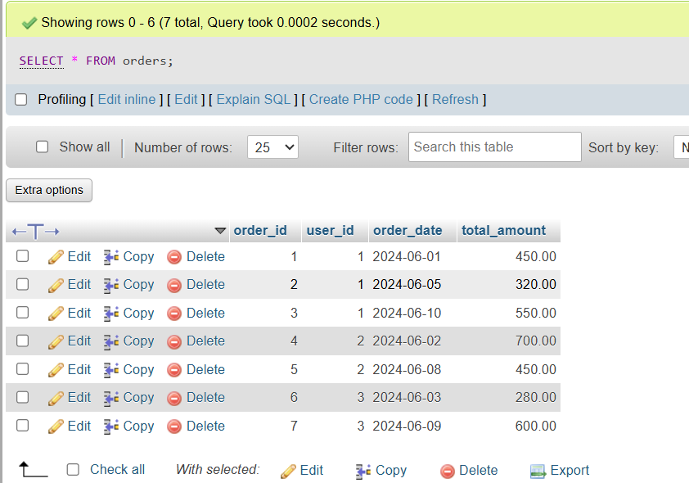

Q2 | Write a SQL query using the LAG() function to show each user's order_id, order_date, and the total_amount of their previous order (if any), ordered by user and date.<br><br><em><strong>Hint:</strong> Use PARTITION BY user_id and ORDER BY order_date in your window function.</em>
Code | SELECT order_id, user_id, order_date, total_amount, LAG(total_amount) OVER ( PARTITION BY user_id ORDER BY order_date ) AS previous_order_amount FROM Orders;
Output | 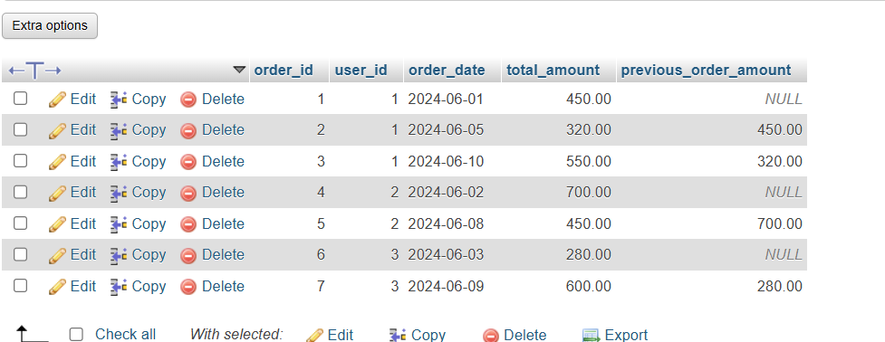

Q3 | Using the same Orders table, write a SQL query with the LEAD() function to display each order_id, order_date, and the next order's total_amount for the same user.
Code | SELECT order_id, user_id, order_date, total_amount, LEAD(total_amount) OVER ( PARTITION BY user_id ORDER BY order_date ) AS next_order_amount FROM Orders;
Output | 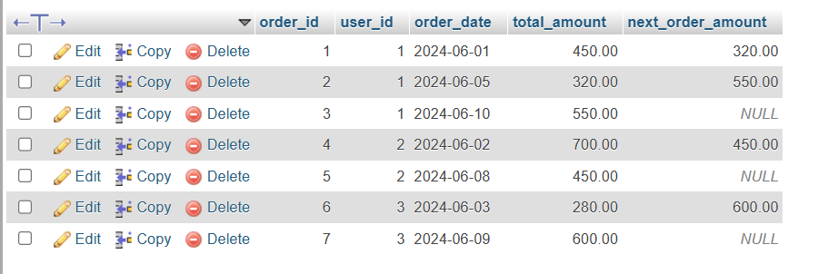

Q4 | Write a SQL query to calculate the running total of total_amount for each user, showing order_id, order_date, total_amount, and a column running_total that accumulates the sum as you move through each user's orders.<br><br><em><strong>Hint:</strong> Use SUM(total_amount) OVER (PARTITION BY user_id ORDER BY order_date ROWS BETWEEN UNBOUNDED PRECEDING AND CURRENT ROW).</em>
Code | SELECT order_id, user_id, order_date, total_amount, SUM(total_amount) OVER ( PARTITION BY user_id ORDER BY order_date ROWS BETWEEN UNBOUNDED PRECEDING AND CURRENT ROW ) AS running_total FROM Orders;
Output | 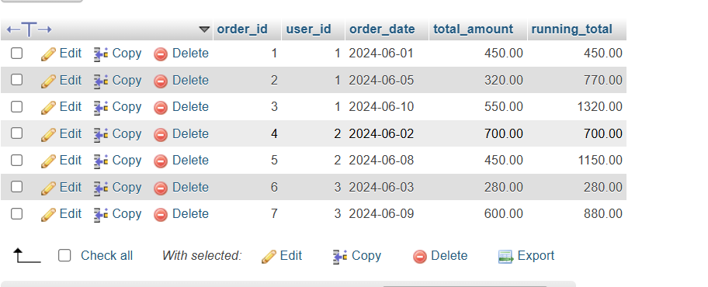

Q5 | Write a SQL query to calculate a 3-order moving average of total_amount for each user, showing order_id, order_date, total_amount, and moving_avg columns.<br><br><em><strong>Constraint:</strong> Use SUM() OVER() with ROWS BETWEEN 2 PRECEDING AND CURRENT ROW to compute the moving average.</em>
Code | SELECT order_id, user_id, order_date, total_amount, SUM(total_amount) OVER ( PARTITION BY user_id ORDER BY order_date ROWS BETWEEN 2 PRECEDING AND CURRENT ROW ) / COUNT(*) OVER ( PARTITION BY user_id ORDER BY order_date ROWS BETWEEN 2 PRECEDING AND CURRENT ROW ) AS moving_avg FROM Orders;
Output | 